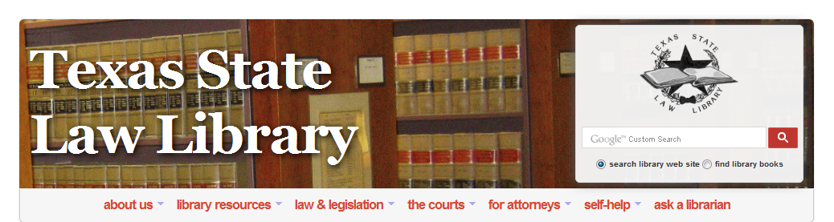
Go to http://guides.sll.texas.gov/databases-a-z . Then register for a library card. Within 24 hours you will be emailed your library card with your number. You can then use all the below databases for free from anywhere. Remember to reregister your card every three months.

Databases available from anyplace other than the Texas State Law Library via your library card.

A

Academic Search Complete (EBSCO)
Administrative Rules and Regulations (Loislaw)
AGRICOLA (EBSCO)
Allt Health Watch (EBSCO)
Aspen / CCH Bankruptcy Law Library (Loislaw)
Aspen Treatise Libraries

B

Bibliography of Native North Americans (EBSCO)
Bromberg & Ribstein on Partnerships (Loislaw)
Business Practice Law Library (Loislaw)
Business Source Complete (EBSCO)
Business Torts Law Library (Loislaw)

C

Case Law (Loislaw)
CCH State-Specific Employment Law Library (Loislaw)
Computer Source (EBSCO)
Construction Law Library (Loislaw)
Consumer Finance Law Library (Loislaw)
Court Rules (Loislaw)

D

Directory of Open Access Journals
Drunk Driving Defense (Loislaw)

E

eBook Collection (EBSCO)
Economia y Negocios (EBSCO)
Elder Law Library (Loislaw)
Employment Discrimination Law Library (Loislaw)
Employment Law Library (Loislaw)
ERIC (EBSCO)
Estate Planning Law Library (Loislaw)
Evidence Library (Loislaw)

F

Family Law Library (Loislaw)
Federal Library (Loislaw)
Fuente Academica (EBSCO)

G

Gale Group Databases Icon
Gale Literature Databases Icon
General Litigation Library (Loislaw)

H

Health Reference Center Academic (Gale Group)
Health Source: Consumer Edition (EBSCO)
Health Source: Nursing/Academic (EBSCO)
Heritage Quest

I

Information Science & Technology Abstracts (EBSCO)
Insurance Law Library (Loislaw)
Intellectual Property Law Library (Loislaw)
Internet & Personal Computing Abstracts (EBSCO)
Internet and E-Commerce Law Library (Loislaw)
L

Law Practice Resources Library (Loislaw)
Legal Collection (EBSCO)
Legal Information Reference Center (EBSCO)
Legal Source (EBSCO)
Library, Information Science & Technology Abstracts
Licensing Agreements Library (Loislaw)
Limited Liability Company Library (Loislaw)
Loislaw

M

MasterFILE Premier (EBSCO)
Mauet Trial Practice Library (Loislaw)
MedicLatina (EBSCO)
MEDLINE (EBSCO)
Medline Plus Icon
Military and Government Collection (EBSCO)

N

National Consumer Law Center
Natural & Alternative Treatments (EBSCO)
Newspaper Source (EBSCO)

O

OCLC WorldCat

P

Personal Injury Law Library (Loislaw)
Product Liability Law Library (Loislaw)
Professional Development Collection (EBSCO)
Psychology & Behavioral Sciences Collection (EBSCO)
Pub Med Central

R

Real Estate Law Library (Loislaw)
Regional Business News (EBSCO)
Religion & Philosophy (EBSCO)
Remedies Library (Loislaw)

S

Salud en Espanol (EBSCO)
Science & Technology Collection (EBSCO)
Section 1983 Litigation Library (Loislaw)
Serials Directory (EBSCO)
State Libraries (Loislaw)
Statutes and Acts (Loislaw)
Stevenson's Legal Forms & Practice Guide for Texas (LoisLaw)

T

Texas Digital Library
Texas Digital Sanborn Maps
Texas Reference Center (EBSCO)
TexShare Databases
Thomas (Library of Congress)
TOPICsearch (EBSCO)

U

U.S. Dept. of State: Background Notes

V

Vocational & Career Collection (EBSCO)

W

World History Collection (EBSCO)

