Guide to Corporate Law Resources

Annotated Statutes:
Title | Location | Description
Vernon’s Texas Statutes and Codes Annotated  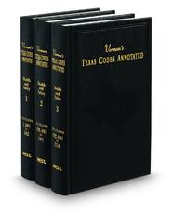 | Circulation Desk &  1st Floor Reading Room (112) | The annotated code for the State of Texas, featuring extensive annotations referencing relevant caselaw and regulations, as well as formbooks, treatises and other secondary resources. Topical indexes are helpful if the researcher is certain they are searching in the right area of law, otherwise it may be advisable to use the multi-volume general index at the end of the set. Vernon’s is also available on Westlaw (TX-ST-ANN) while Lexis’ version of the Texas Statutes and Codes can be found on Lexis-Nexis (CODE)
O’Connor’s Business Organizations Code Plus / Business & Commerce Code Plus  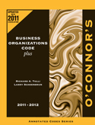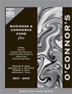 | Circulation Desk  KFT1407 .A3 /  KFT1352 .A33 | A favorite of practitioners, these single volume annotated codes contain statutory text organized into subject area, along with quotations from relevant cases. The Business Organizations Code Plus features the entire BOC along with other statutes and regulations relating to corporate practice. Meanwhile, O’Connor’s Business & Commerce Code includes the Texas UCC and other transactional statutes. Not currently available online.
Delaware Code Annotated  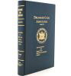 | 1st Floor Reading Room (100) | Title 8 of Lexis’ Annotated Code for Delaware on Corporations is most relevant while Title 6 (Commerce and Trade), Title 18 (Insurance), Title 19(Labor), Title 30 (State Taxes), and others may also be useful. The Delaware Code Annotated is available on Lexis (CODE) while West’s version of the Delaware Code Annotated is available on Westlaw (DE-ST-ANN).  [No longer updated as of July 2013.]
The Delaware Law of Corporations & Business Organizations Statutory Deskbook  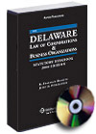 | 2nd Floor KFD213 .A29 D44 | This compilation of Delaware statutes is generally less heavily annotated than the full Delaware Code above, but provides a single, convenient source for relevant Delaware statutes, including the full text of Title 8 (Corporations), the Limited Liability Company Act from Title 6 and the Statutory Trust Statute, along with laws on partnerships, non-profit corporations and other areas. Recent amendments are also highlighted in brief introductory sections. Not available online.

Secondary Sources:
Title | Location | Description
Texas Transaction Guide: Legal Forms  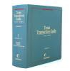 | Circulation Desk  KFT1268 .K45 | The Library’s most popular treatise on Corporate Law in Texas, providing extensive commentary, practice forms, and research guides listing primary and secondary sources. Volumes 1-6 on Business Entities contain information on formation and operation of corporations, partnerships, and LLCs while volumes 10-15 focus on commercial transactions, including contracts, sales, and secured and consumer transactions. Also available on Lexis (TEXTRN).
Texas Practice Series: Business Organizations  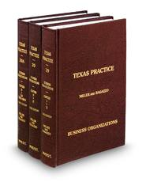 | Circulation Desk  KFT1280 .T4 | Volumes 19-20A of West’s Texas Practice Series provide extensively footnoted commentary on various areas of corporate practice in Texas, including partnerships, LLCs, professional entities and for-profit corporations. The set also includes a limited number of forms. The Texas Practice Series is available on Westlaw (TX-PRAC).
Texas Practice Guides: Business Entities/  Business Transactions  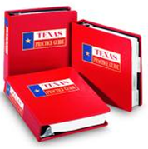 | Reserve Room  KFT1405 .B37  KFT1352 .R52  KFT1352 .A6 | These multi-volume treatise sets contain very concise explanatory sections, along with forms, practice checklists and references to applicable statutes, caselaw, and West’s topical digests. All Texas Practice Guides are available on Westlaw (TXPG-ALL) along with individual volumes: Business Entities (TXPG-BUSEN); Business Transactions (TXPG-BUSTR).
Texas Corporation Law  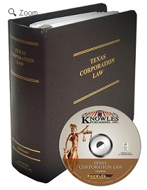 | Reserve Room  KFT1414 .N48 | This single-volume treatise provides commentary on various aspects of corporate practice in Texas, from formation and governance to dissolution. The text contains references to caselaw and statutes while a bibliography of secondary sources is included in the Appendix. Forms may be found on the accompanying CD-ROM disk. Not available online.
The Delaware Law of Corporations & Business Organizations  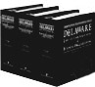 | 2nd Floor  KFD213 .B353 | This three volume loose-leaf set provides extensive coverage of Corporate Law in Delaware with the first volume and part of the second devoted exclusively to explanatory text on the formation and governance of corporations and other business entities. The balance of the second volume and the entire third volume are devoted to statutes and forms, respectively. The set is also available on Westlaw (DELCBO).

Secondary Sources (continued):
Title | Location | Description
Treatise on the Law of Securities Regulation  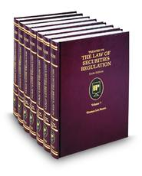 | 2nd Floor KF1439 .H39 | Hazen’s 7 volume treatise focuses primarily on the regulation of securities at the federal level, including registration and reporting requirements, exemptions and liability issues. The set begins with a general overview of securities law practice before covering individual topics in greater detail. The set is also available on Westlaw (LAWSECREG).
West’s Texas Forms: Business Entities  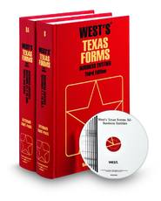 | Circulation Desk  KFT1268 .W477 | Volumes 8 and 8A of West’s Texas Forms provide guidance for drafting a vast array of documents related to corporate practice in Texas. Forms relating to state and federal taxation and securities regulation are presented along with examples of internal and external communications, formation and governance documents, and other sample documents for corporations and other businesses. Each chapter includes a brief introduction providing background information while individual forms include cross-references to statutes and other materials as well as brief explanatory notes offering additional guidance. Also available on Westlaw (TXFORMS)

Note: General Materials on Business Organizations, Agency, Securities, etc. can be found on the second floor of the Law Library and in the Reserve Room between KF1341 – KF1480.

